IBM HR Analytics Attrition Analysis
INFO 584 - Data Visualization
Professor Serhat Simsek
March 4, 2025

Group 4
Prakrity Choukade
Sanjana Maruf Orpa
Hana Bucinca
Jaya Devi

Table of Contents
Abstract 3
Introduction & Motivation 3
Dataset Overview 4
Analysis & Findings 4
Department-Wise Attrition 4
Gender-based Attrition 5
Attrition & Job Satisfaction 5
Attrition based on Income & Years since last Promoted 6
Attrition based on Marital Status 8
Attrition based on Job-level in each Age Group 8
Attrition by Promotion & Tenure (Years) 9
Dashboard 11
Conclusion 12
References 13

Abstract
Employee attrition presents a significant challenge for organizations, affecting productivity, operational efficiency, and overall business success. This study explores factors contributing to attrition using the IBM HR Analytics Attrition Dataset. By leveraging data analysis and visualization techniques, key patterns and trends are identified to provide actionable business insights. The research examines relationships between employee demographics, job roles, salary, and other workplace factors to determine their influence on employee turnover. Key findings suggest that low salary, job dissatisfaction, young age, and single marital status are the primary drivers of attrition. Additionally, the highest attrition rates are observed in Sales and Research & Development (R&D) departments, particularly among Sales Representatives and Research Scientists. These insights highlight the need for strategic interventions, such as competitive compensation, career growth opportunities, and targeted retention strategies, to reduce turnover effectively.

Introduction & Motivation
Organizations face a pressing need to manage employee attrition effectively to maintain workforce stability and reduce costs associated with turnover. According to Gallup's State of the Global Workplace (2023)¹ report, voluntary turnover has been a significant concern, with companies facing substantial losses in productivity and rehiring expenses as a result. Understanding the key drivers of attrition is essential for organizations to develop effective retention strategies.
Existing research highlights multiple factors influencing attrition, including salary, job role, department, and work environment. Artelt & Gregoriades (2023)² emphasize the role of work-life balance, lack of growth opportunities, and workplace stress as primary drivers of attrition. Similarly, Yang & Islam (2020)³ found that salary, age, and job history significantly impact employee retention.
This study employs data analysis and visualization techniques to uncover trends in employee attrition. The primary objectives include:
Identifying the main drivers of attrition.
Assessing the impact of salary and work-life balance on retention.
Analyzing turnover rates across job roles and departments.
Using Tableau, we processed the data, developed visualizations, and constructed dashboards to present meaningful insights. These findings will aid organizations in making data-driven decisions to reduce attrition and enhance employee satisfaction.

Dataset Overview
This study utilizes the IBM HR Analytics Attrition Dataset4 available on Kaggle, compiled by Pavan Subhash. The dataset contains records of 1,470 employees and includes 35 variables spanning employee demographics, job attributes, and work-life balance metrics. Key variables include age, department, job role, education, work-life balance ratings, job satisfaction, monthly income, years at the company, and attrition status (Yes/No).
Before analysis, the dataset underwent preprocessing, including handling missing values and ensuring categorical variables were structured correctly. The dataset was well-structured, requiring minimal changes, allowing for seamless integration into Tableau. The dataset's depth enabled a comprehensive examination of attrition trends, including salary disparities, department-wise turnover, and the influence of promotions on retention.

Analysis & Findings

Department-Wise Attrition
A department-wise analysis revealed that:
- Sales had the highest attrition rate at 56.12%.
- Research & Development (R&D) followed with 38.82%.
- Human Resources (HR) had the lowest attrition at 5.06%.
These results suggest that attrition is highly concentrated in Sales and R&D, warranting targeted retention strategies for these departments.
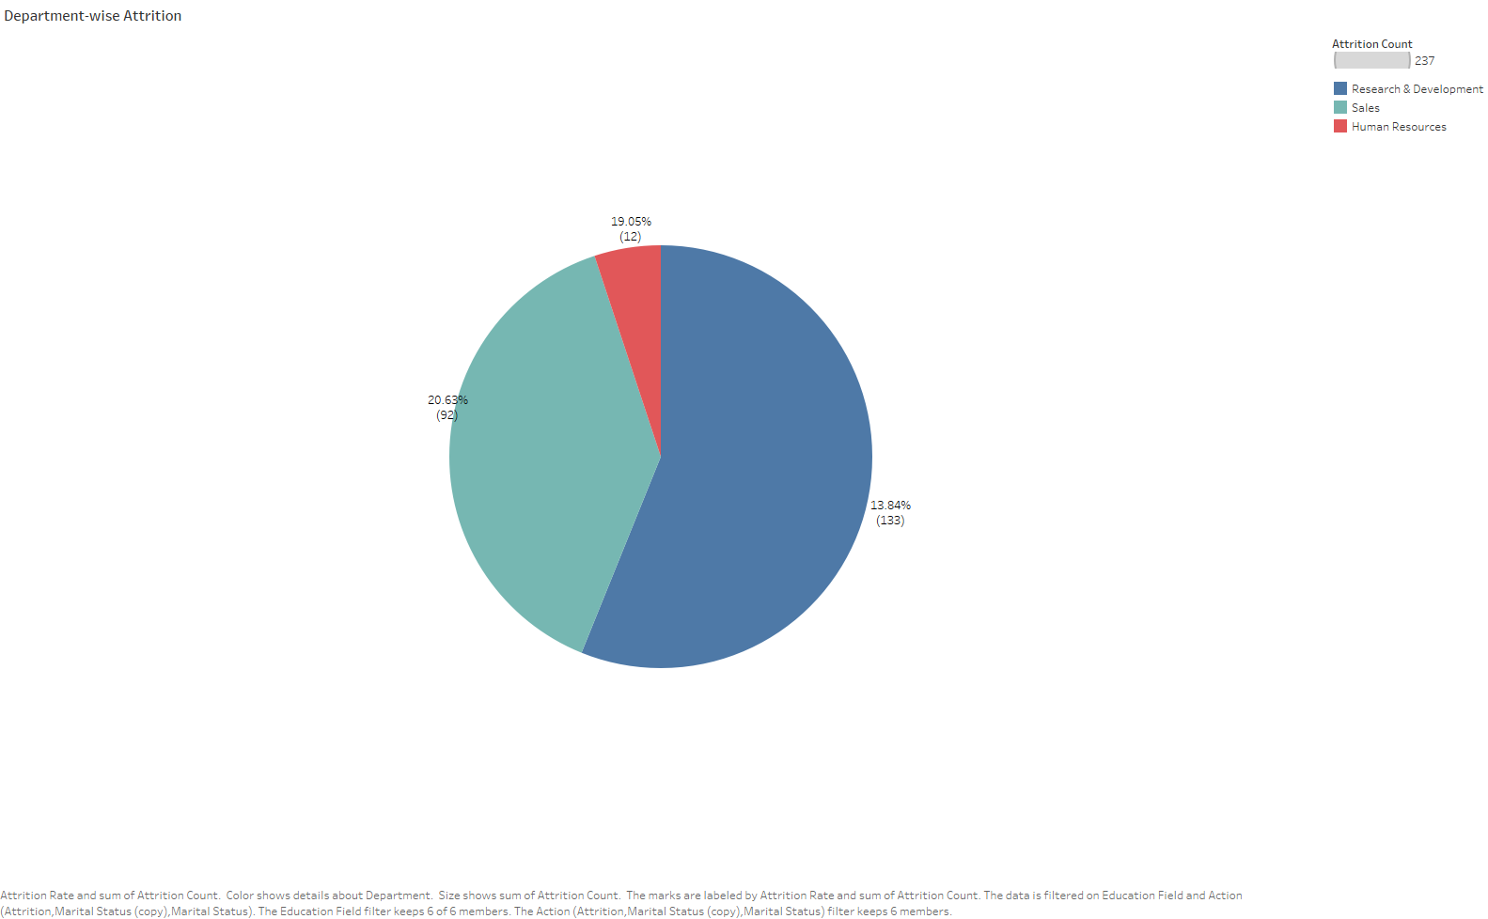

Gender-based Attrition
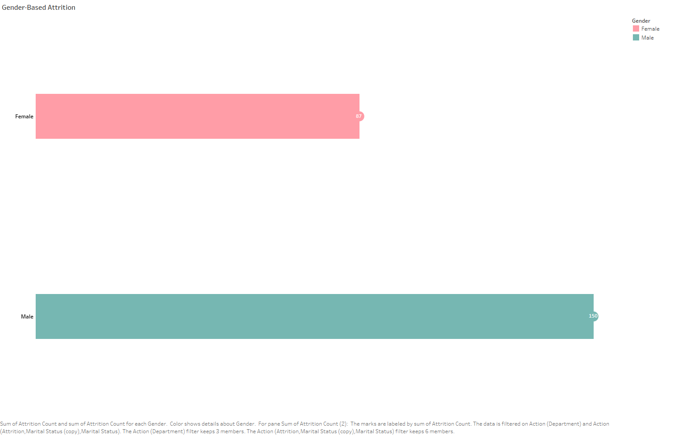
The gender-based attrition chart shows that 150 male employees and 97 female employees have left the organization. While the absolute attrition count is higher for men, the attrition rate relative to total employees in each gender group provides a clearer picture. The attrition rate for females is 16.5% (total females 589), whereas for males, it is 17% (total males 881). This indicates that while more men have left in absolute numbers, the attrition rates for both genders are relatively close, with males experiencing a slightly higher rate of departure.

Attrition & Job Satisfaction
Examining job satisfaction levels across roles, we found that:
- Sales Representatives and Research Scientists exhibit high attrition across different job satisfaction levels - from Low to Very High - aligning with the high attrition rates observed in the first visualization. This suggests that even employees who report high job satisfaction may still be leaving at notable rates, indicating that factors beyond satisfaction, such as workload or external job opportunities, may contribute to turnover.
- Managers and Research Directors experience relatively lower attrition, possibly reflecting stronger retention among leadership positions. This could be attributed to greater job stability, clearer career growth opportunities, or differences in work demands that make these roles more sustainable in the long term.
While job satisfaction ratings vary across roles, even employees with Medium or High satisfaction levels show notable attrition in certain job functions, reinforcing the idea that satisfaction alone is not a sufficient predictor of retention and that structural and job-specific factors may play a more significant role in driving turnover.
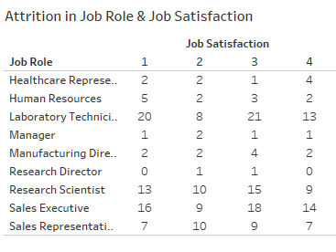

Attrition based on Income & Years since last Promoted
A visualization of monthly income and years since the last promotion revealed:
- Employees with lower salaries and recent promotions (0-1 year ago) exhibited higher attrition rates.
- Attrition occurred across various salary ranges, indicating that salary alone is not a definitive factor in employee turnover.
These findings suggest that organizations should focus on structured career growth plans rather than solely relying on promotions or salary increases to enhance retention.
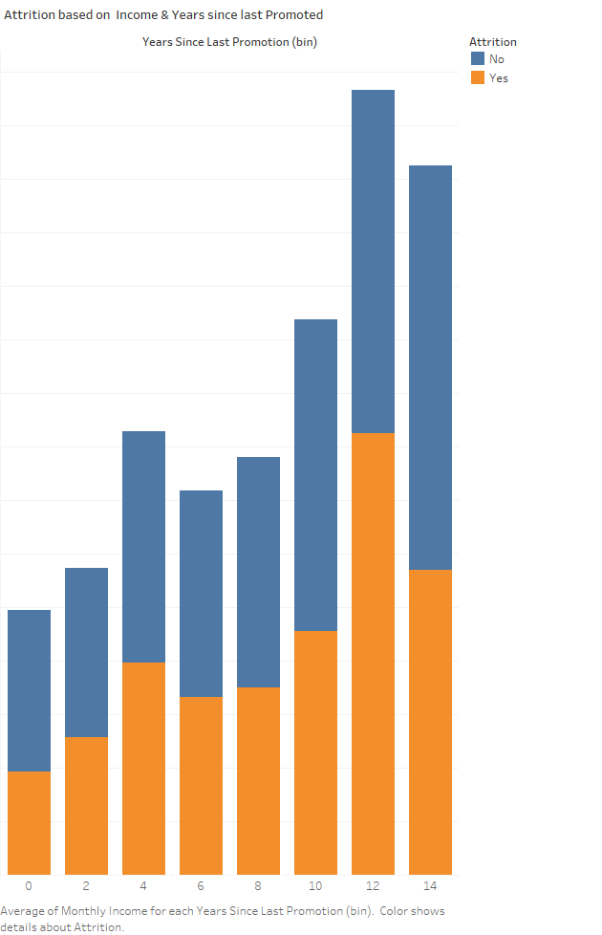

Attrition based on Marital Status
Analysis of attrition based on marital status found:
- The turnover rate was higher among single employees compared to their married or divorced counterparts.
- Married employees exhibited the lowest attrition, possibly due to greater job stability or financial obligations.
This pattern indicates that personal circumstances play a role in attrition trends, necessitating personalized retention strategies.
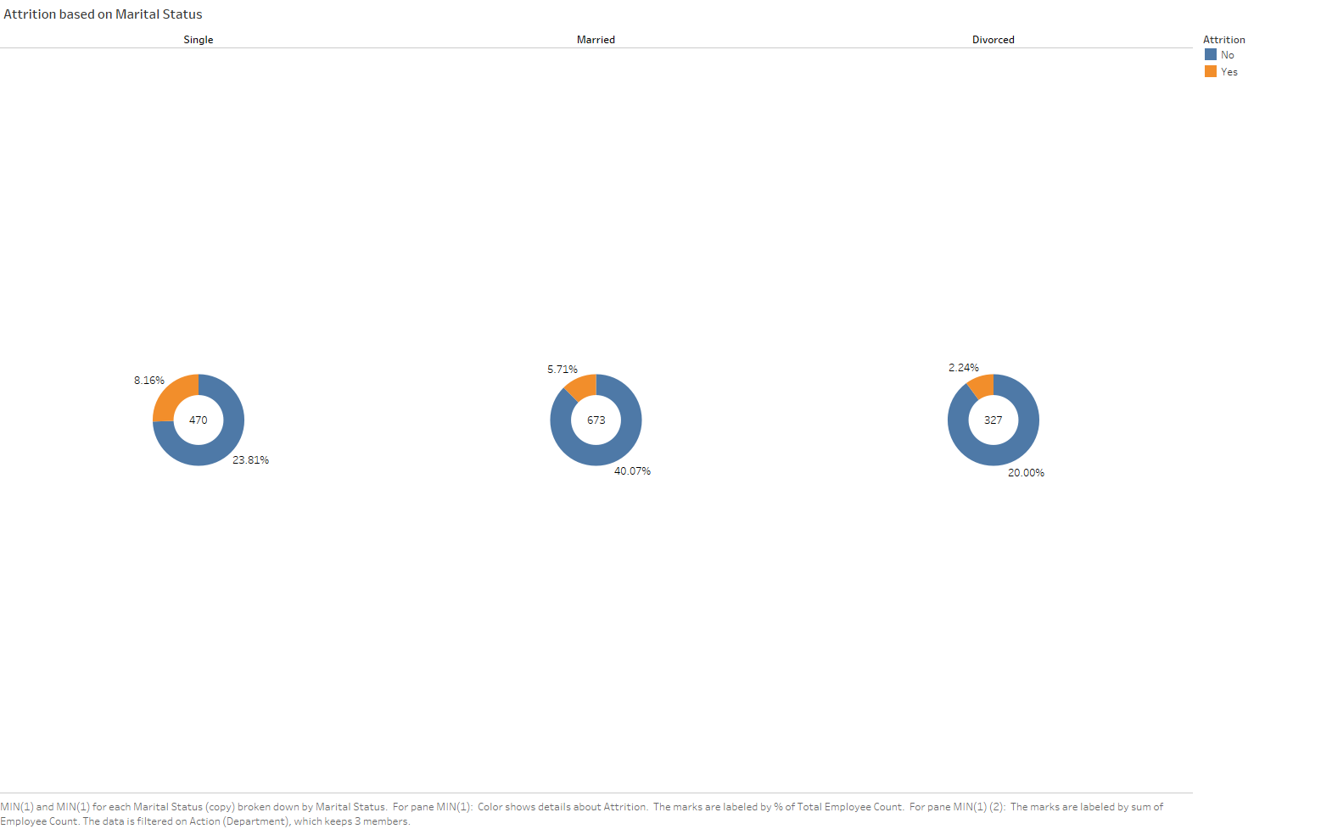

Attrition based on Job-level in each Age Group
A heat map visualization of attrition across different age groups and job levels highlighted:
- High attrition among younger employees (ages 18-29) at lower job levels (1-2).
- Attrition decreased as job level increased, suggesting career advancement plays a key role in retention.
- Employees aged 40+ showed lower attrition, indicating greater job stability.
Organizations should focus on retaining young employees in entry-level positions by offering career development programs, mentorship, and structured promotion pathways.
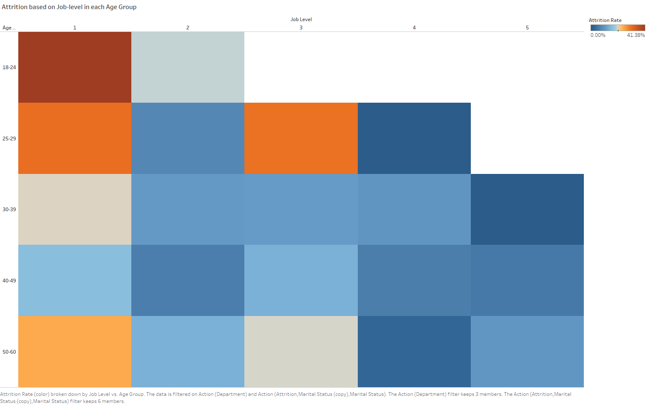

Attrition by Promotion & Tenure (Years)
The area chart visualizes employee attrition based on years since the last promotion (red) and total tenure at the company (blue).
Key insights:
- High attrition among new employees – Employees with less than one year of tenure have the highest attrition, indicating early turnover is a major concern.
- Recently promoted employees (0–2 years) are more likely to leave – Despite career advancement, attrition remains high, suggesting promotions alone may not be enough for retention.
These findings suggest that organizations should focus on providing long-term career growth opportunities and job stability to retain newly promoted employees and those with short tenure.
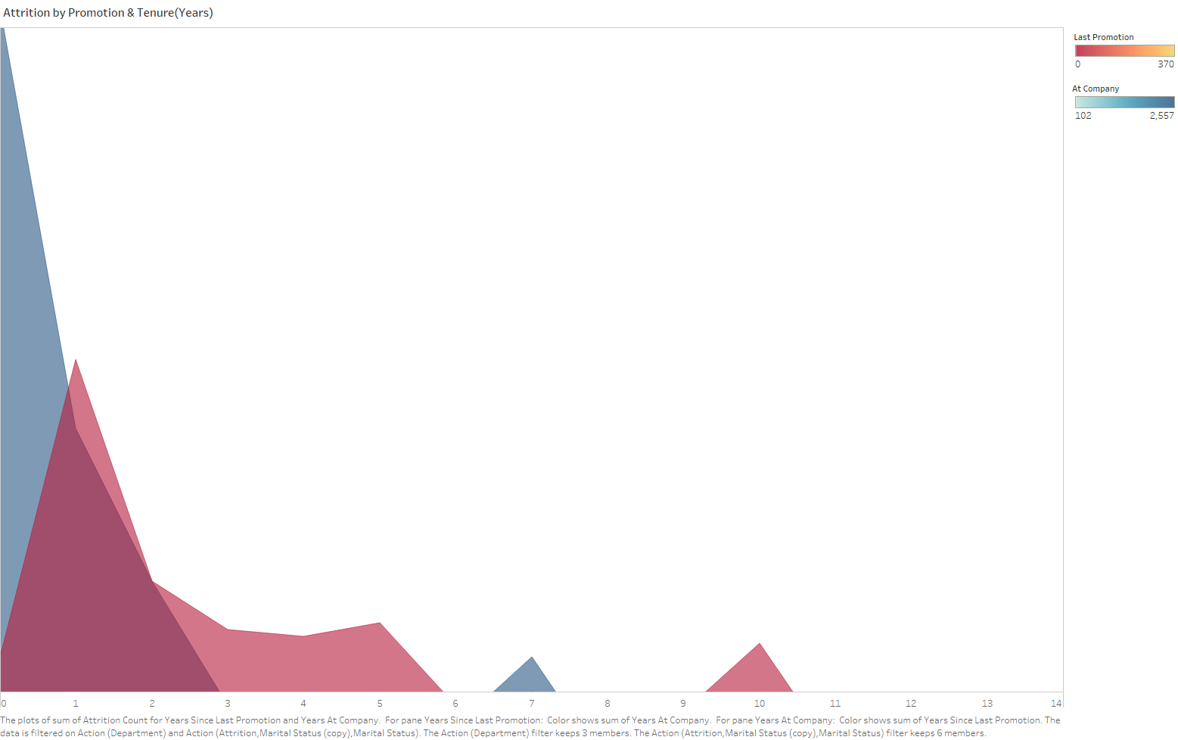

Dashboard
Link to our Dashboard published in Tableau Public
Filters:
- Education Level
- Gender
- Department
- Marital Status
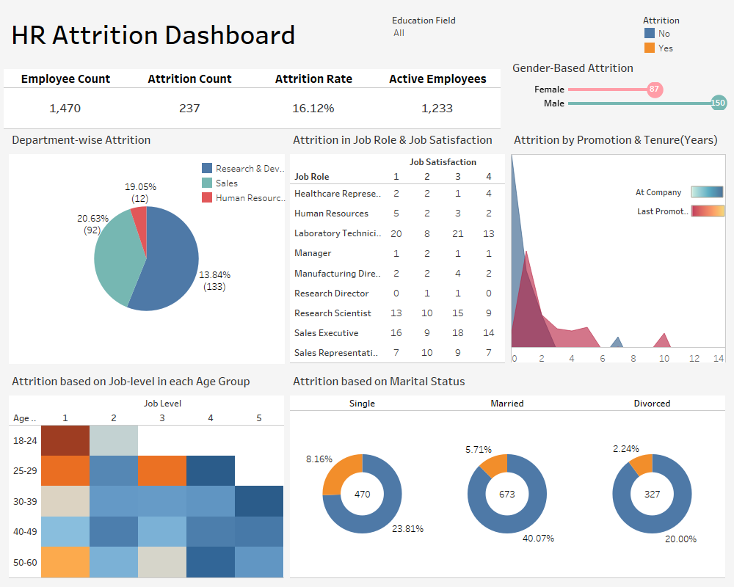

Conclusion
This study reveals that the main drivers of employee attrition include low salary, job dissatisfaction, young age, and single marital status. While salary significantly affects retention, lack of career growth and dissatisfaction with job roles contribute heavily to turnover. The highest attrition rates are observed in the Sales and Research & Development (R&D) departments, particularly among Sales Representatives and Research Scientists.
Over time, attrition patterns show that younger employees and those recently promoted tend to leave at higher rates, emphasizing the need for better onboarding, career development, and engagement strategies.
To reduce attrition, HR can implement the following strategies:
- Competitive Compensation & Benefits: Regular salary adjustments based on market trends and performance.
- Career Growth Opportunities: Clear promotion paths, mentorship programs, and skill development initiatives.
- Employee Engagement & Recognition: Regular feedback sessions, recognition programs, and fostering a positive work culture.
- Targeted Retention Strategies: Special retention initiatives, including retention bonuses, for high-risk groups like new hires and high-performing employees.
Organization can develop proactive retention strategies, improve employee satisfaction, and minimize turnover by utilizing data-driven insights.

References
- Gallup. (2023). State of the global workplace: 2023 report. Gallup.
- Artelt, A., & Gregoriades, A. (2023). Predicting employee attrition using machine learning techniques.
- Yang, S., & Islam, M. R. (2020). An analysis of employee attrition factors using data mining techniques.
- IBM. (n.d.). IBM HR Analytics Employee Attrition & Performance Dataset. Retrieved from [IBM HR Analytics Dataset].

